COMMUNITY NEWS · PIKESVILLE
Cranes, Hard Hats, and a Promise Kept: Construction Begins at Miriam’s Library
Six months after 4,000 donors bought a building, the hard hats have arrived — and the goal is in sight: after-school programming for Baltimore’s children, beginning this coming school year.
BALTIMORE, MD | June 2026 | Community Report
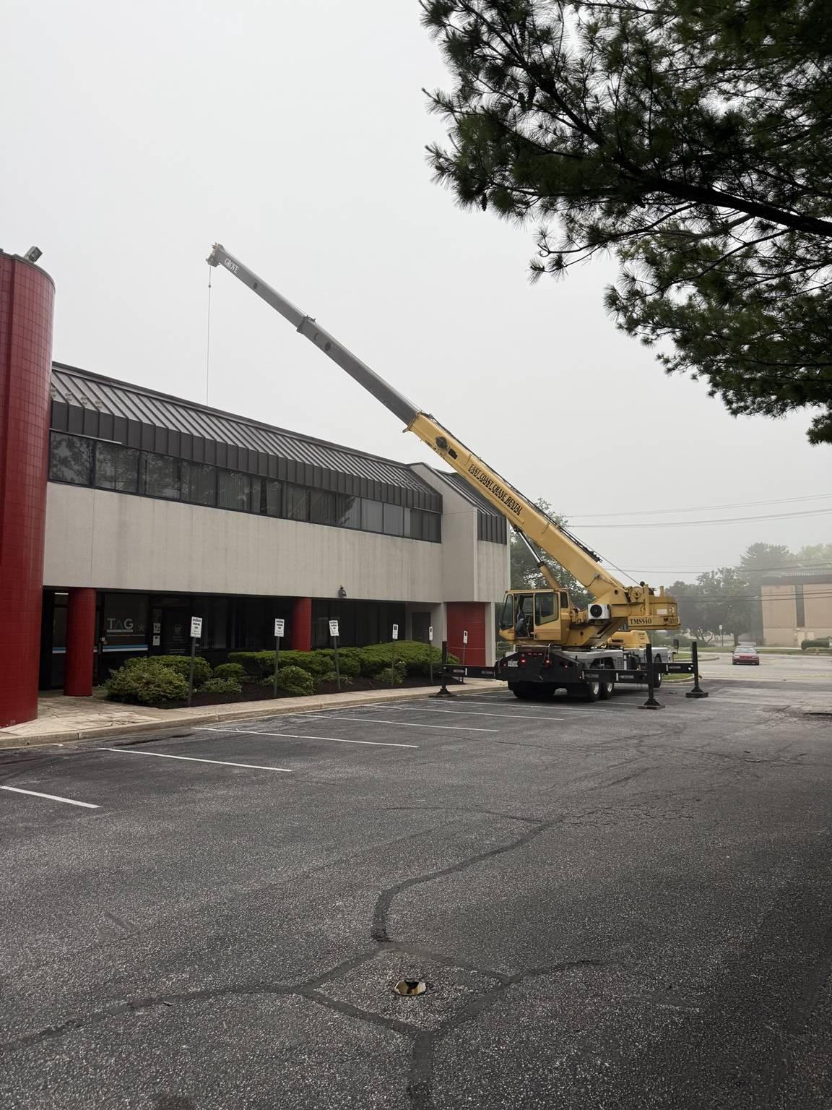
Boom day. A crane towers over 201 Milford Mill Road in June as exterior work gets underway. The 14,000-square-foot building, directly across from the Pikesville Armory, was purchased on closing day this past December.
If you drove past 201 Milford Mill Road this month, you saw something that didn’t exist a year ago: a crane, a work crew, and a building mid-transformation. The hum of a generator where there used to be an empty lot of waiting. After months of paperwork, permits, and quiet preparation, Miriam’s Library and Learning Center has reached the milestone the community has been waiting for — construction has begun, with one clear target ahead: opening the doors to after-school programming for the coming school year.
It is a long way from where this started: a tribute evening, a grieving husband, and a vision most people would have filed away as a beautiful idea. Instead, Mendel Mintz turned the memory of his late wife, Mrs. Miriam (Fink) Mintz a”h, a beloved special educator, into bricks, drawings, and now an active job site.
INSIDE THE WALLS
Step through the door of the Phase One suite today and you won’t find a library — not yet. You’ll find the honest, dusty middle of a renovation: ceiling tiles pulled, wiring exposed, old carpet rolled and stacked against the wall, ready to be hauled out. It is the least glamorous stage of any building project, and to the people who have followed this from the beginning, it may be the most beautiful.
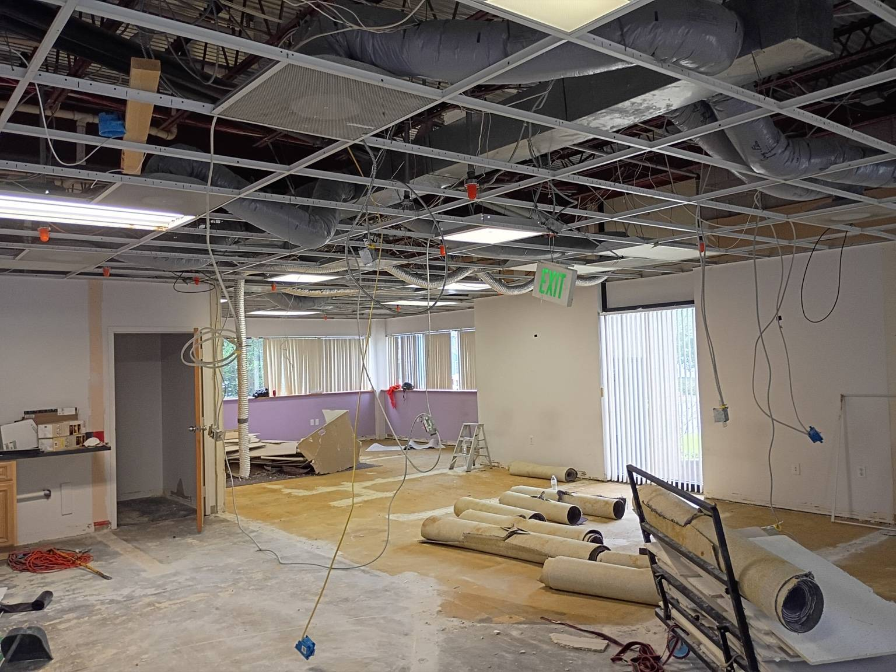
The honest middle. Interior demolition inside the 1,400-square-foot Phase One suite. The exposed ceiling and stripped floor are the first physical steps toward a warm, flexible learning space for children.
That 1,400-square-foot suite is the opening move in a much larger plan. Rather than wait years to renovate all 14,000 square feet at once, the organization chose to open a smaller space first — begin serving children sooner, learn what families actually need, and build the rest responsibly. Phase One is designed to begin small, learn quickly, and grow.
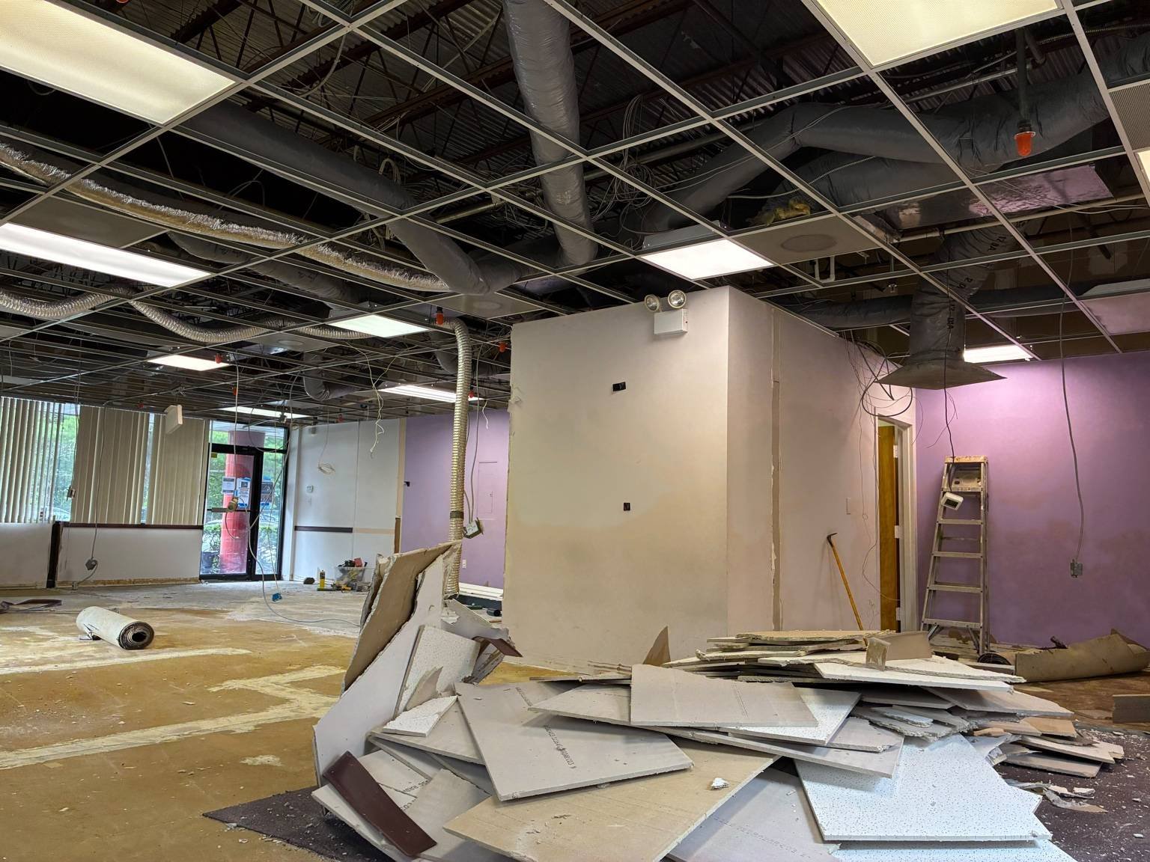
Down to the bones. Removed ceiling tiles and drywall pile up as the old office layout comes apart, clearing the way for the new tutoring and learning zones.
THE COMMUNITY SHOWS UP — IN PERSON
The building has also become a destination for Maryland’s elected leadership. Through May, a striking roster of officials toured the site and sat down to hear the plan: House Speaker Joseline A. Peña-Melnyk, Senator Shelly Hettleman, Delegates Dana Stein, Cheryl Pasteur, Jon Cardin, and Samuel Rosenberg, Baltimore County Councilman Israel “Izzy” Patoka, and Jane Lichter, Chair of the Baltimore County Board of Education, among others.

Eyes on the vision. Mendel Mintz welcomes elected officials and education leaders to the building during a spring site visit. The visits turned letters and phone calls into face-to-face support.
The visits weren’t only ceremonial. Baltimore County followed through with a $35,000 capital grant toward Phase One’s STEM lab and activity space — the organization’s first government award, and a signal to other funders that this project is real and moving.
Behind the construction sit three quieter wins: the IRS expedited the center’s 501(c)(3) status, existing building tenants were kept on through 2027 to help carry costs, and new foundation and government funding channels were opened — so the work can outlast a single campaign.
OPEN FOR THE NEW SCHOOL YEAR
The whole effort is pointed at a single date: this coming school year. When Phase One opens its doors, targeted for September 2026, it will begin with what the community needs most — after-school programming for local children. That means tutoring and homework support, digital learning and structured enrichment, and Heichal HaBaal Shem Tov programming, all in a space designed, from the floor up, around children. The aim is for students to walk in this fall to a consistent, welcoming place to learn and grow after the school day ends.
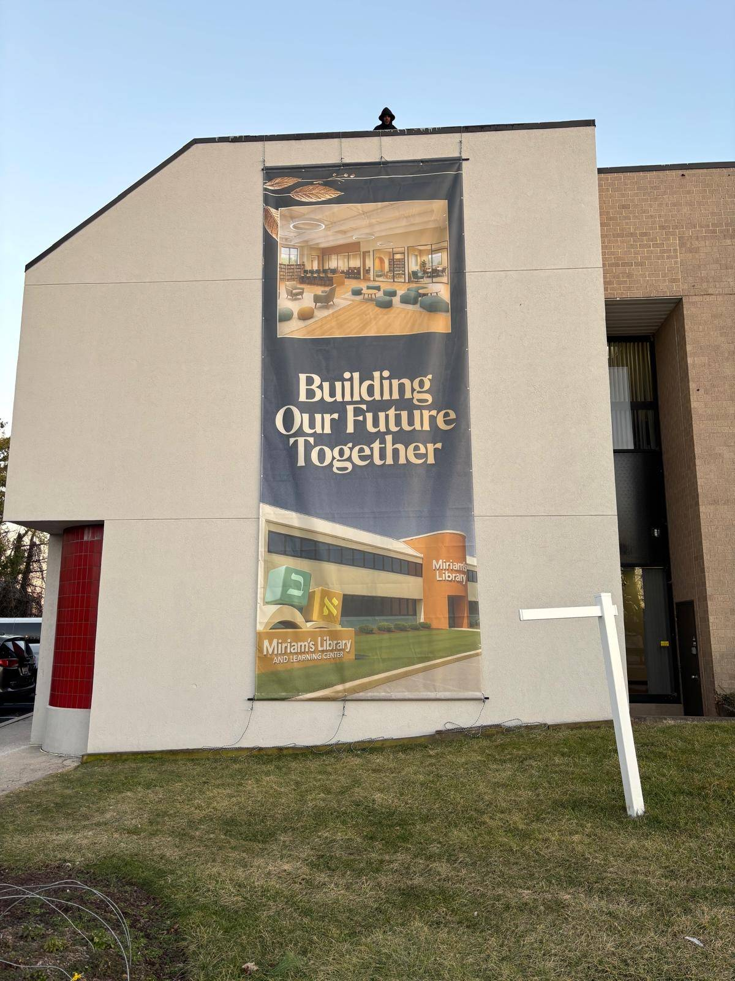
Building our future together. A banner on the Milford Mill Road building tells passersby what’s coming. Phase One is the beginning — the long-term plan calls for the full 14,000-square-foot center, then a campus-style expansion.
The program is already being built alongside the building. Mrs. Esther Ehrman has joined as Program Director, planning the schedule, instructors, and opening-year experience so that the moment the dust settles, the after-school program is ready to run — not months later, but for the school year now beginning.
For a project born out of loss, the sound of construction carries a particular kind of meaning. Miriam Mintz spent her life making sure children who learned differently were never left behind. On Milford Mill Road this summer, that work is no longer a memory or a rendering. It is a building going up, one wall at a time.
Miriam’s Library and Learning Center · 201 Milford Mill Road, Pikesville, Maryland

